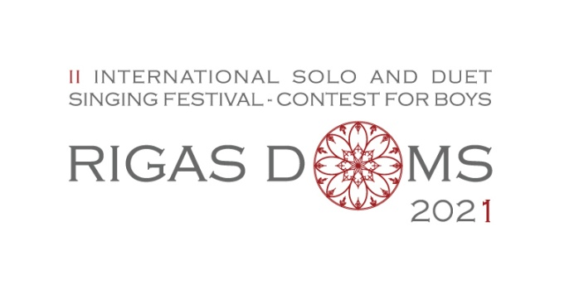
APPLICATION FORM
SOLO SINGING

Send application by e-mail to competition@nmv.lv
Deadline: October 15, 2021

CONTESTANT’S DETAILS

Full name
Birth Date |  |  | Day, month, year
The organizers have the right to view contestant’s birth certificate, identity card or passport

Country represented , Music school
Achievements in other competitions

APPLICANT’S DETAILS
Applicant's Name
E-mail
Phone Number
TEACHER'S DETAILS
Full name
Teacher's Number
E-mail
REPERTOIRE OF THE CONTEST
 | FIRST ROUND
A folk song a cappella
TITLE
KEY
TIMING
A composition of academic music of choice with piano accompaniment
TITLE
COMPOSER
TIMING
 | SECOND ROUND
A composition of academic music of choice
TITLE
COMPOSER
TIMING
A composition of choice
TITLE
COMPOSER
TIMING

Will you to use an accompanist offered by the organiser?
Will you perform with his own accompanist?
Accompanist Name
DOCUMENTS TO ATTACH
Attach Repertoire scores to the application form by e-mail!

REGULATIONS
http://www.rdks.lv/rigas-doms-eng/

I hereby accept the competition rules (X)

