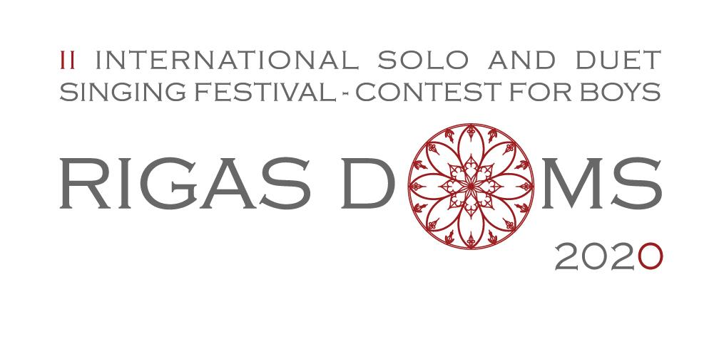
Application Form
SOLO SINGING

Send application by e-mail to competition@nmv.lv
Deadline: January 15, 2020
CONTESTANT’S DETAILS

Full name
Birth Date
The organizers have the right to view contestant’s birth certificate, identity card or passport
Country represented
Achievements in other
competitions
APPLICANT’S DETAILS
Applicant's Name
E-mail
Phone Number
TEACHER'S DETAILS
Full name
Music school
Address
Teacher's Number
E-mail
REPERTOIRE OF THE CONTEST

FIRST ROUND
1. A folk song a cappella
TITLE
KEY
TIMING
2. A composition of academic music of choice with piano accompaniment
TITLE
COMPOSER
TIMING
Will you to use an accompanist offered by the organiser?
Will you perform with his own accompanist?
Accompanist Name
SECOND ROUND

1. Compulsory composition
Group A - ERIKS EGLITIS "AGNUS DEI"
Group A - ULDIS STABULNIEKS "AVE MARIA"
Group B - MARIS LASMANIS "AVE MARIA"
Group B - INGA SARKANE "AVE MARIA"
2. A composition of academic music of choice
TITLE
COMPOSER
TIMING
DOCUMENTS TO ATTACH
- Repertoire scores
- Demo video recording of a performance or link to the Demo video _____________________________________________________________________________

REGULATIONS
http://www.rdks.lv/en/rigas-doms-eng/

I hereby accept the competition rules

